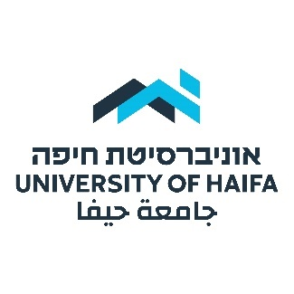

**The Division for Diversity, Inclusion and Community**

*Advancing Excellence and Inclusion at the University of Haifa*

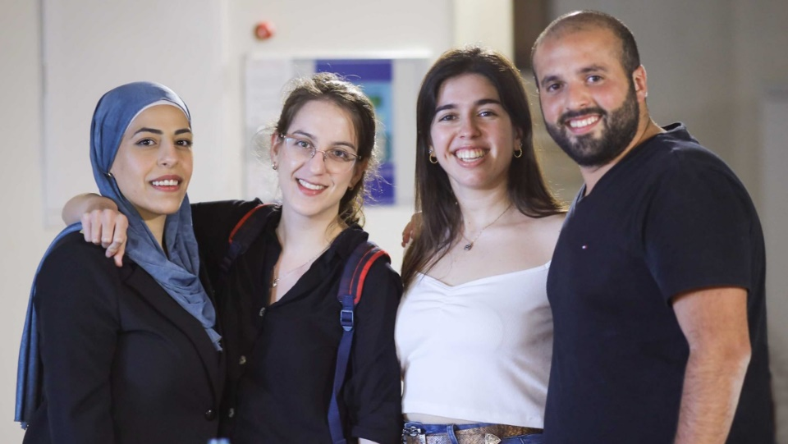

The University of **Haifa's Division for Diversity, Inclusion and Community** is dedicated to embracing the rich tapestry of human experiences within our community, recognizing diversity as a cornerstone of academic and research excellence. Through initiatives that expand and enrich our university community, foster a sense of belonging, and leverage the power of diversity, we strive to create an inclusive environment where every individual can flourish.

Our objectives include creating an equitable academic and social environment, celebrating the diversity of our student body and faculty, embracing diversity as a strength, nurturing diverse and inclusive student leadership, developing innovative practices for a multicultural campus, bridging the language gap, promoting Arabic language and culture, and building a national and international reputation for diversity and inclusion.

**Building a Shared Society**

In response to recent challenges, including tensions between Arab and Jewish students, the University of Haifa is launching a series of initiatives to promote dialogue, understanding, and cooperation on campus. These initiatives utilize various approaches, including leadership development programs, language study, community engagement, and art projects, to create a more inclusive and cohesive campus environment.

1. **The Multi-Ethnic Young Leadership Program**

The Multi-Ethnic Young Leadership Program seeks to empower a cohort of 40 committed Arab and Jewish university students to become change agents in Israeli society. Through an intensive two-year program focused on identity exploration, dialogue, and community service, we aim to foster better understanding and cooperation between Arab and Jewish students.

The Multi-Ethnic Young Leadership Program was developed by the Office of the Dean of Students under the direction of Dr. Yael Granot-Bein, who has extensive experience in creating and evaluating shared society programs. The Office's Community Engagement Unit has a solid track record of developing multicultural programs that promote dialogue and address conflict resolutions, including The El Sabil Program for Druze Women; The Druze Social and Academic Leadership Program; the Entrepreneurship for Shared Society in the mixed city of Akko; and HaifaLead – creating shared spaces in the city of Haifa, to name a few.

1. **Our Walls Can Talk**: **Jewish and Arab Students** **Transforming Campus Walls into Murals**

This project, titled "Our Walls Can Talk," uses art as a bridge for connection and dialogue between Arab and Jewish students. Recognizing that words sometimes fall short, the project utilizes shared artistic expression to foster deeper understanding and communication.

The project unfolds in four distinct stages:

* **Individual Expression**: Separate meetings are held with both Arab and Jewish students, allowing them to express themselves freely and prepare for the collaboration.
* **Joint Dialogue**: A unified session brings students together to discuss themes of shared living, open dialogue, and personal symbolism, laying the groundwork for their collaborative artwork.
* **Creative Collaboration**: A dedicated "Arts Day" provides students with the opportunity to co-create artwork under the guidance of faculty members, fostering collaboration and artistic expression.
* **Reflection and Sharing**: A final meeting allows students to reflect on their experience and document their insights, making the project's outcomes accessible to the entire campus community.

This innovative project harnesses the power of art to facilitate emotional expression, foster communication, and cultivate trust, all while reinforcing the values of a multicultural campus and shared society. Through the creation of a lasting monument, the project aims to convey a resounding message of friendship and social solidarity, while also denouncing racism and hatred. By maintaining its enduring presence and hosting ongoing educational activities, the monument will serve as a powerful vehicle for spreading this message far and wide, contributing to a more inclusive and harmonious community.

1. **The Study of Spoken Arabic by Non-Arab Students**

This initiative outlines a plan to introduce spoken Arabic courses for non-Arab students at the University of Haifa. By offering language training and facilitating interactions between Arab and non-Arab students, the program aims to promote shared society values and cultural understanding on campus.

The proposed program aims to foster intercultural understanding and community engagement through three key components:

**Enhanced Arabic Language Learning**: Non-Arab students will have the opportunity to learn spoken Arabic under the guidance of experienced instructors, enriching their academic experience and cultural understanding.

**Peer Mentorship and Friendship**: An established tutoring system will pair Arab students with non-Arab peers, creating a space for learning outside the classroom and fostering valuable friendships.

**Shared Responsibility Workshops**: Through facilitated workshops, Arab and non-Arab students will explore their common ground and shared responsibility within Haifa. This collaboration will empower them to develop initiatives that bridge cultural divides, such as organizing joint events and activities for Jewish and Arab communities.

The program's ripple effects are expected to transform both the campus environment and the wider Haifa community. On campus, we anticipate a visible shift as Jewish and Arab students break down social barriers and engage in shared initiatives, fostering a climate of mutual understanding. Beyond the university, students will lead new projects that champion tolerance and appreciation among Haifa's diverse populations. Additionally, the program will cultivate a group of Arabic-speaking Jewish citizens, not only empowering them as advocates for increased Arabic language study but also setting a powerful example that will inspire future learners both on campus and throughout the city.

**Additional Shared Society Initiatives**

1. **Empowering Women from the Ultra-Orthodox (*Haredi*) Communities to Pursue Advanced Degrees**

*Haredi* women in Israel often face significant hurdles integrating into the workforce due to limited educational opportunities. University of Haifa's new initiative aims to break this cycle by supporting ambitious Haredi women seeking doctoral degrees. These women, already established leaders in their communities and careers, often juggle demanding roles as mothers and managers while pursuing advanced studies in fields like economics and education. Despite their remarkable dedication, they encounter challenges such as gaps in recent academic experience and limited research skills.

The proposed program addresses these specific needs by providing comprehensive support encompassing financial assistance, empowering group workshops, and personalized academic mentorship. By bridging the gap between their aspirations and the academic barriers they face, the program empowers these women to navigate their doctoral journeys with confidence, paving the way for not only their own success but also serving as inspiring role models for their children's societal integration.

1. **Helping formerly Ultra-Orthodox** **(*Haredi*) Students Integrate into Israeli Higher Education**

A significant number of young ultra-Orthodox adults make the challenging decision to leave their insulated communities. Many of these individuals, eager to pursue higher education, encounter formidable barriers due to their unconventional backgrounds. Lacking foundational subjects like English, mathematics, and science, formerly *Haredi* students confront challenges in gaining admission, assimilating into university life, and attaining academic success.

To address these obstacles and ensure equitable access to educational opportunities, the University of Haifa is taking a proactive approach. This entails acknowledging the unique needs of these students and providing targeted support to bridge the academic disparity. Such support may include offering enrichment courses to bolster their proficiency in core subjects or facilitating access to mentorship programs and support networks that offer guidance and camaraderie during their transition.

1. **Promoting Academic Excellence among Israeli-Ethiopian Students**

University of Haifa is committed to supporting Israeli-Ethiopian students to excel in their academic pursuits and to secure employment opportunities upon completing their studies. Recognizing the unique challenges faced by these students, including cultural adjustment, language barriers, and limited access to professional networks, the program offers a comprehensive range of resources and support services tailored to their needs.

Through mentorship, academic guidance, and career development workshops, the proposed program will empower these students to succeed academically and navigate the complexities of the job market. Additionally, the program fosters a sense of community and belonging by facilitating networking events, cultural celebrations, and peer support groups. By providing holistic support from enrollment to graduation and beyond, the University of Haifa initiative aims to transform the educational experience for Israeli-Ethiopian students and pave the way for their future success.