

**A New Era in Marine Exploration:**

**Supporting AI-Based AUV Operations**

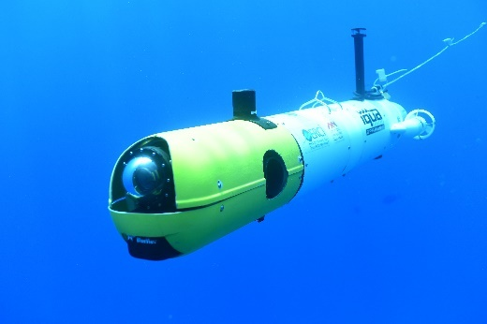In our ongoing efforts to comprehend and safeguard our oceans amidst unprecedented challenges, technological innovations based on the operations of **Autonomous Unmanned Vehicles** (AUVs) emerge as transformative tools for scientific inquiry. Equipped with AI-powered sensors for precise imaging, navigation and positioning, AUVs offer significant capabilities to propel marine exploration, support environmental sustainability efforts, and enhance maritime security.

University of Haifa scientists and engineers at the Hatter Department of Marine Technologies are at the forefront of groundbreaking research and development in underwater technologies and data-driven exploration and monitoring, paving the way for a more sustainable future. Under the direction of Department Chair, Prof. Yizhaq Makovsky, the team is developing AI tools and advanced robotics applications to improve autonomous navigation and decision making. These tools enable cost-effective seafloor inspection, ecological mapping and characterization, and a variety of real-time submarine operations.

The University of Haifa's research agenda extends to several key areas:

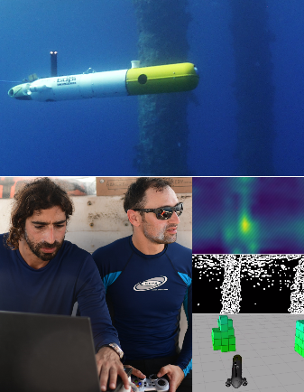**Science-Based Sustainability Research**. Leveraging the advanced capabilities of AUVs, the University of Haifa team is dedicated to exploring the critical intersections of science-based sustainability, conservation, and marine resources exploration. This research agenda aligns closely with global frameworks such as the UN Sustainable Development Goals and the COP15 initiative, which aim to conserve 30% of marine environments by 2030.

**Training a New Generation of Expert Marine Scientists and Engineers in Israel**. Prof. Makovsky emphasizes the importance of instilling a 'Profession for Life' ethos in University of Haifa graduate students, ensuring their ongoing dedication to marine research and preservation. By providing comprehensive education and training, we are cultivating a new generation of marine experts ready to tackle tomorrow's challenges and propel Israel to global leadership in marine sciences and technologies.

**Strengthening Environmental Stewardship**. Initiatives like the @NET program provide opportunities to cultivate curiosity and passion for the sea among Israel's youth and high school students, especially in peripheral areas. Through strategic partnerships with organizations like @NET and MASA, we can increase awareness about the critical importance of the marine environment, inspiring future stewards of our oceans.

**Enhancing National Security for Israel**. Addressing both human and natural threats to Israel's coastal regions is a priority. Our research and initiatives contribute to enhancing national security measures, ensuring the protection of vital marine and coastal assets and territories.

**Promoting Israel's Blue Economy**. Researchers at the Department of Marine Technologies are committed to harnessing the vast potential of marine resources to drive sustainable economic growth and development. By promoting innovation and investment in the Blue Economy, we strive to create a prosperous and resilient future for generations to come.

**The Impact of Intelligent AUV Operations**

The operations of the AUV encompass a diverse range of applications, each with the potential to significantly enhance safety and sustainability within Israeli society.

1. 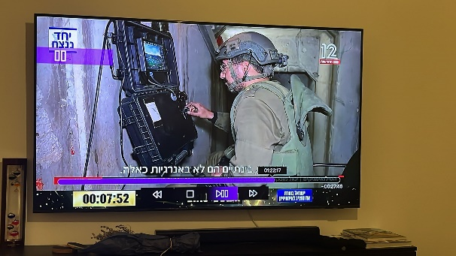**Supporting IDF Operations:** We maintain a close partnership with the IDF and Ministry of Defense, focusing on autonomous vehicle navigation. Our AUV-related initiatives contribute to the development at the Department of sophisticated security systems that are being utilized by dozens of IDF units in critical lifesaving applications.
2. **Improving Ocean Health:** Utilizing AI tools and advanced algorithms, our research enables AUVs to operate in hazardous marine environments with precision facilitating precise mapping of disaster zones and comprehensive investigations of underwater objects. These capabilities enable swift disaster response and recovery efforts, contributing significantly to the preservation of ocean health and marine habitats. For example, our work has already led to the establishment of Israel‘s largest by far marine protected area and the first in the country’s exclusive economic zone beyond its territorial waters.
3. **Educational Outreach:** The University of Haifa's Youth Science education initiatives play a pivotal role in instilling values of environmental stewardship and introducing hundreds of schoolchildren to the captivating world of marine research. Our cutting-edge AUV research serves as a cornerstone in these educational endeavors, offering hands-on learning opportunities and sparking curiosity about marine ecosystems and conservation efforts.

**Request for Support:**

We invite you to partner with the University of Haifa to ensure that our research remains at the forefront of marine research and innovation. Your generous support will play a pivotal role in advancing AI navigation for marine ecology preservation and naval operations.

* **A generous gift of $1 million** will facilitate advanced operations of a Minor AUV. The donor's name will be prominently displayed on the vehicle.