A Proposal to Support
The Public Impact Program
A Joint University of Haifa-Aharai! Initiative

The University of Haifa and “Aharai!” (Follow Me!) have partnered to offer a special undergraduate degree program for “Aharai” alumni. The Public Impact program will provide highly motivated “Aharai” alumni, many of whom come from underserved communities, with a comprehensive “envelope” of support services and enrichment activities. The goals of the initiative are to ensure that Aharai graduates experience a smooth entry into higher education, stay on the path to graduation and acquire indispensable knowledge, skills and tools to make an impact on Israeli society.

We are seeking funding over a three-year period to provide student scholarships and to support the enrichment programming. Your support will ensure that these students achieve their fullest academic potential and succeed in their chosen career paths.

The Public Impact Program at the University of Haifa

The “Public Impact Program” – a joint venture of UofH and Aharai! – was founded with the mission of nurturing high quality young leadership in minority communities.

Participants will enroll in a specially designed double major degree in Political Science and Jewish History. The curriculum will focus on the most challenging issues facing Israeli society, with an emphasis on expanding the participants’ worldviews, developing their personal and professional identities and helping them gain a more nuanced perspective on leading social change initiatives.

The program combines professional training, seminars, networking, meetings with high- profile public sector figures, and mentoring, internships.

We take very seriously our responsibility to provide a comprehensive “envelope” of counselling and tutoring services to the Aharai! alumni – many of whom are first-generation university students. In most cases, they require individual assistance throughout their academic careers to overcome the numerous barriers to success that are unique to this underserved student population.

The “Public Impact Program” provides an exceptional opportunity for these highly motivated youth to earn an academic degree, find meaningful work and make a significant impact on Israeli society.

University of Haifa

The University of Haifa’s distinctive mission is to foster academic and research excellence in an atmosphere of tolerance and multiculturalism. Our campuses are academic home to 18,000 students and faculty members from different ethnic, religious and socioeconomic backgrounds. Jews, Arabs, Druze, new immigrants, international students, IDF officers and security personnel come together to study, research, socialize, and prepare themselves for the challenges of a rapidly changing world.

Through an accelerated growth strategy, the University has established Israel’s first “Multiversity” – a multi-campus institution that promotes extensive interdisciplinary studies and partnerships. The Multiversity is designed improve access to higher education in the North, better prepare students for a dynamic job market and serve as a catalyst for economic expansion and strengthening Israel’s northern region.
Aharai!

Aharai! is a social and educational organization that develops leadership and promotes social involvement among youth from development towns, absorption centers, boarding schools and youth villages.

Aharai! recruits youth at a critical crossroad of life when their futures can still be influenced by education, positive role models and a caring community.

By connecting participants to milestones in Israeli society – such as preparation for a significant military service in the IDF, matriculation exams, and gap year community service programs – the organization provides its young members with a sense of achievement and competence and encourages them to fit in as contributing citizens in the State of Israel.

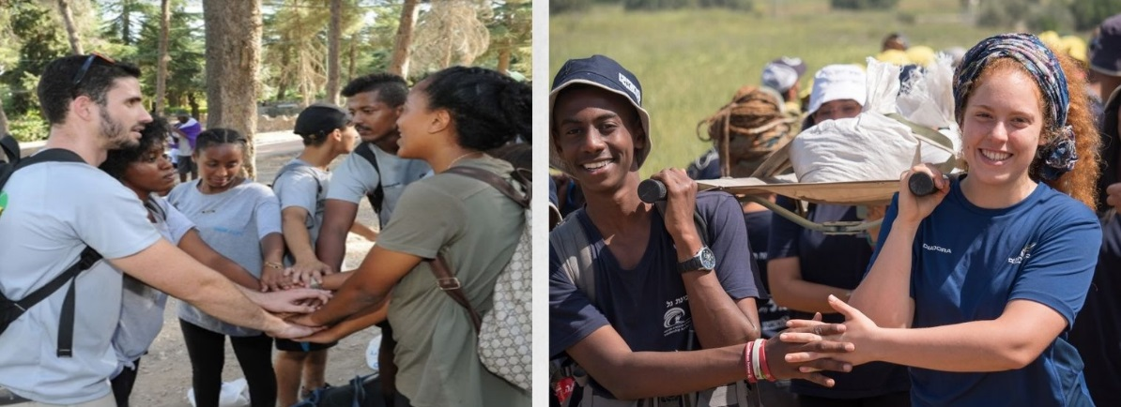

Request for Support
- A gift of $225,000 for 3 years will enable graduates of Aharai! to attend “The Public Impact Program". Your support will ensure that these students achieve their fullest potential – academically, in their communities and in the job market.

