|  |  |  |  |  |  |  |  |  |
| --- | --- | --- | --- | --- | --- | --- | --- | --- |
| |  | | --- | |  | | MOMENTS OF REFUGE: mindfulness-based trauma recovery for refugees  In response to Israel's refugee crisis, UofH researchers have developed a highly innovative, evidence-based initiative to help refugees heal, one moment at a time.  The Moments of Refuge Project is a first-of-its-kind mindfulness- and compassion-based intervention program that is trauma-sensitive and socio-culturally adapted for diverse forcibly displaced people in Israel and around the world.  The program is now set to play an important role in the growing global refugee crisis.  **MOMENTS OF REFUGE SUPPORTS UN SUSTAINABILITY GOAL #3 – GOOD HEALTH AND WELL-BEING. (see appendix)** | |  | |  | |  | | --- | | mental health intervention tailored to refugees and asylum seekersscience with a human rights missionfirst-of-its-kind intervention programRAMPING UP to save lives around the world | |  | | "OUR RESEARCHERS ARE DEVELOPING Local solutions WITH A global IMPACT."   * President Ron Robin | |

**Pioneering Mental-health Intervention  
to Improve the Wellbeing of Refugees**

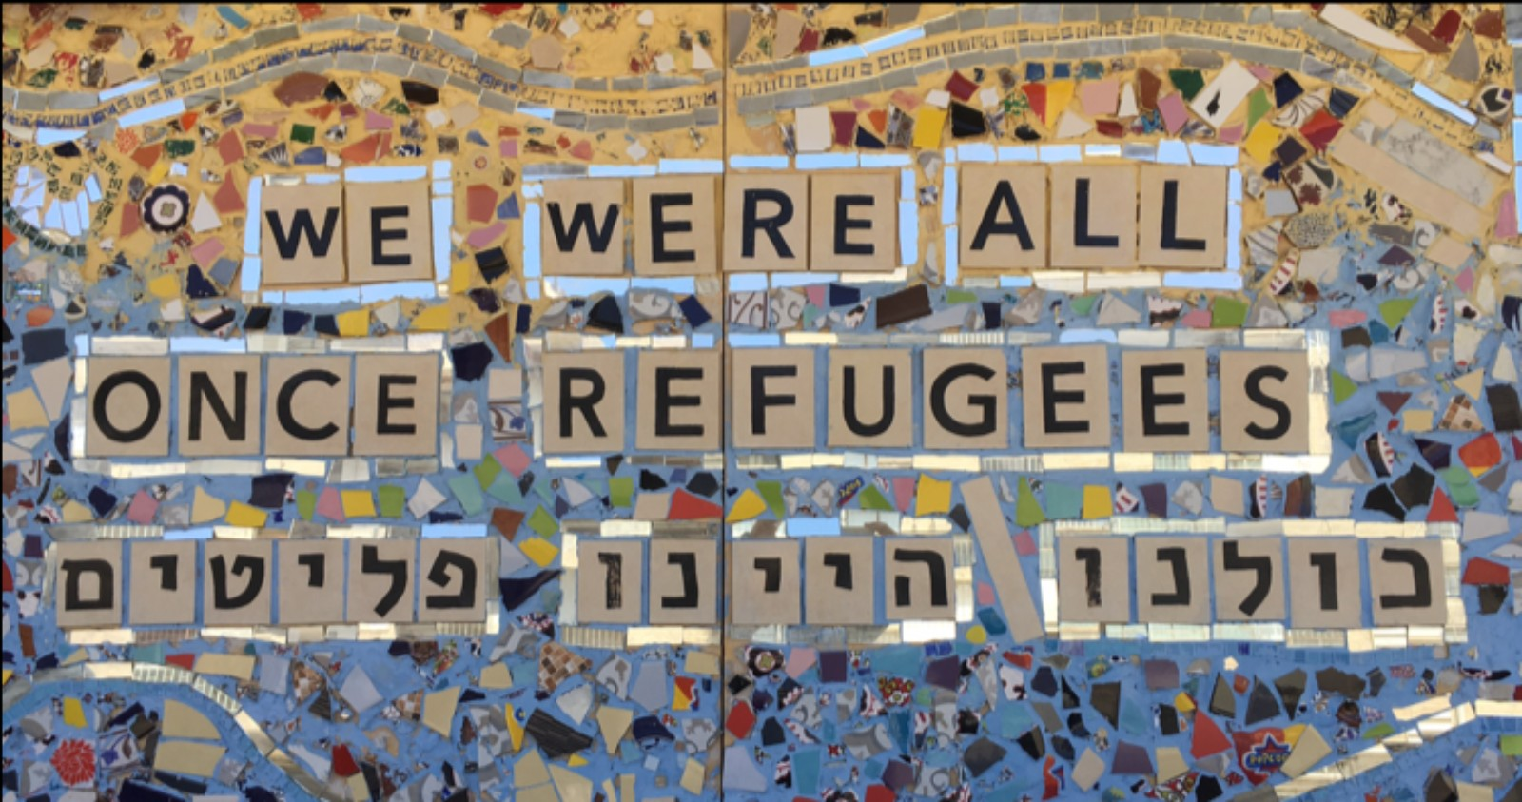

**Background**

An unprecedented 82.4 million people worldwide have been forcibly displaced from their homes by conflict, persecution, natural disasters. An estimated 35 million (42%) of the 82.4 million forcibly displaced people are children below 18 years of age. (https://www.unhcr.org/refugee-statistics/) These displaced persons are subject to violence, torture and sexual assault. In addition to the stresses of physical survival and migration, many experience severe mental health issues of trauma, loss and chronic stress post-displacement. The COVID 19 pandemic escalated the severity of this crisis across the globe and the numbers continue to rise.

Beginning in 2006, waves of asylum seekers from East Africa (primarily Eritrea and Sudan) traversed the Sinai Peninsula and crossed the southern border with Egypt to seek refuge in Israel. Many arrive in Israel with high and persistent rates of posttraumatic stress disorder and depression.

**Mindfulness-Based Trauma Recovery for Refugees**

In 2011, Prof. Bernstein and his team set up a mobile “satellite laboratory” in the Tel Aviv Central Bus Station area, the epicenter of Israel's refugee community, to study the community and offer counselling. Following several years of working with the African asylum-seeker community, the team developed a highly innovative therapeutic approach to help refugees heal, one moment at a time. The **Mindfulness-Based Trauma Recovery for Refugees** (MBTR-R) approach is a first-of-its-kind mindfulness- and compassion-based intervention program that is trauma-sensitive and socio-culturally adapted for diverse forcibly displaced people in Israel and around the world.

|  |  |
| --- | --- |
|  | "The mindfulness program has given me tools to help me gain control of my feelings. The meditations have made me more focused and less angry at home."  *- M., refugee from Eritrea after completing the 9-week Mindful Trauma Recovery Program* |

MBTR-R led to significant improvements in stress- and trauma-related mental health outcomes (PTSD, depression, anxiety, and wellbeing). Furthermore, they found that MBTR-R is safe for even for the most highly traumatized sanctuary seekers (e.g. former child soldiers, torture survivors, and survivors of human trafficking).

**Moments of Refuge Project**

Prof. Bernstein is working now closely with the asylum-seeker community, NGOs, human rights activists and leading inter-disciplinary scientists around the world to expand and replicate the Moments of Refuge Project.

“We recently secured grants from the Israel Science Foundation (ISF) and the Mind and Life Institute to join a national network in Italy that is bringing together universities, NGOs and local government to assist the large refugee population there,” adds Bernstein. “We will be working with our partners in Italy to test the 'community-participatory', culturally-sensitive model within different cultures of origin and contexts, and to study the efficacy and safety of the intervention itself.”

Moments of Refuge seeks to therapeutically and systemically change the current and future of a generation of forcibly displaced people through the dissemination, implementation, scaling and parallel rigorous scientific study of the MBTR-R approach. Now, and over the coming decade, Prof. Bernstein and team are working to reach and impact forcibly displaced people, their families and communities around the world.

**Responding to the COVID-19**

The COVID-19 pandemic and the public policies that were implemented to limit the spread of the virus disproportionately affected the refugee community. The team carried out the first-ever empirical study of the mental health among asylum-seekers due to economic, housing and food insecurity due to COVID-19 public policies. They documented that as many as 54% of women in the asylum-seeker community experienced acute suicidality during the COVID-19 lockdowns.

The team quickly pivoted and developed a mobile health (online platform) adaptation of MBTR-R – **Mindfulness-SOS for Refugees**. Over the past year it was, and still is, used directly by individuals, families and communities of forcibly displaced people in Israel and around the world. It is already available in multiple languages, including Arabic, and used by asylum seekers in Israel and around the world. The team carried out an open-trial of Mindfulness-SOS during the national lockdown. Again, they found strong evidence for the feasibility and therapeutic efficacy of the program.

**My Year of Living Mindfully**

The Moments of Refuge Project was featured in the award-winning documentary "My Year of Living Mindfully" ([**https://www.myyearoflivingmindfully.com**](https://www.myyearoflivingmindfully.com)). In addition, Prof. Bernstein took part in a documentary panel discussion where he candidly shares the rationale and humanitarian goals of his research activities. ([**https://youtu.be/xU6EUqArES0**](https://youtu.be/xU6EUqArES0))

**Future Plans**

**The Moments of Refuge Project requires significant resources to expand its activities in Europe and Africa.** This support will enable us to establish partnerships with universities, mental health professionals and NGO's in other countries and reach additional refugee communities that are suffering from trauma, posttraumatic stress disorder and depression.

**Academic Leadership**

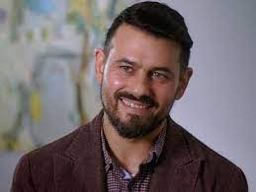Prof. Amit Bernstein (PhD. University of Vermont) was born in Israel and raised and educated in the United States. He completed a Postdoctoral Research Fellowship at the Department of Psychiatry and Behavioral Sciences at Stanford University School of Medicine. In 2008, Amit returned to Israel and joined the Department of Psychology at the University of Haifa as an Israeli Council for Higher Education Yigal Alon Fellow.

Prof. Bernstein's laboratory – The Observing Minds Lab – is dedicated to helping those who struggle and suffer live better lives. His research focuses on how mental health and illness are shaped by the ways in which we process, experience and respond to our internal states. In partnership with members of the E. African refugee community and NGOs dedicated to their wellbeing, his team also runs a small satellite laboratory from the South Tel Aviv Central Bus Station – dedicated to the mental health of forcibly displaced persons (e.g., refugees, asylum seekers from E. Africa) who have survived traumatic atrocities and violent conflict.

*We thank you for your consideration of this project.*

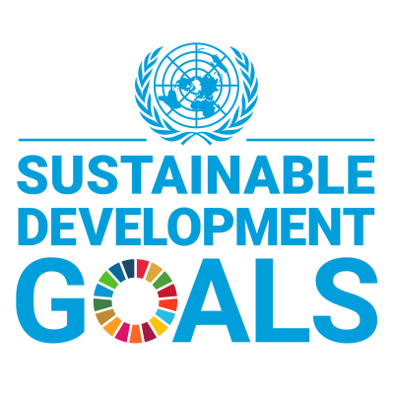

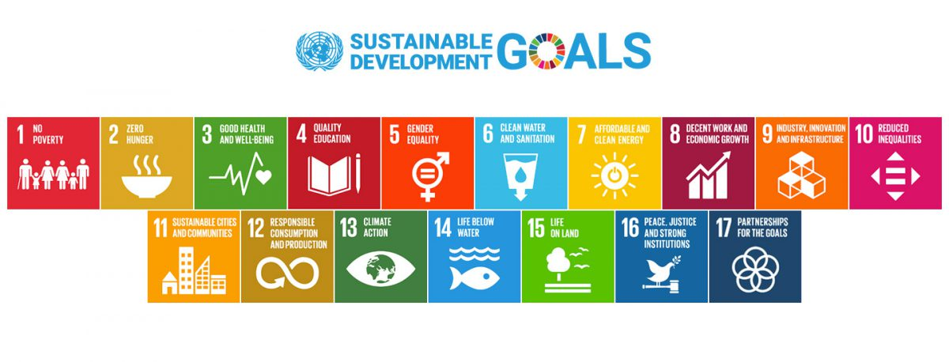

|  |
| --- |
| **University of Haifa is committed to the UN's 17 Sustainable Development Goals (SDGs) and is actively participating in global efforts that aim to create a better future for the planet, humanity and Israeli society.** |

The Sustainable Development Goals were adopted by the United Nations in 2015 as a universal call to action to end poverty, protect the planet, and ensure that by 2030 all people enjoy peace, health and prosperity.

Universities have a unique and critical role in helping the world achieve the Sustainable Development Goals through their research, teaching, operations and community engagement.

University of Haifa is the first Israeli higher education institution that is committed to undertaking research, providing relevant educational opportunities and operating its campuses in a manner that is making a positive contribution to achieving the SDGs.

