|  |  |  |
| --- | --- | --- |
| https://eng.industry.org.il/files/Englishsite/ima%20new%20logo.png?v=123123 |  | Image result for herta and paul amir faculty |

*A Proposal to Establish*

**The Institute for Social and Economic Research**

*A Joint Initiative of the University of Haifa &*

*The Forum for Reducing Gaps in Israel Society and the Manufacturers Association* *of Israel*

Despite strong economic growth, Israeli society is characterized by high and increasing levels of socioeconomic inequality as compared with most OECD countries. Israel’s most acute economic problem is the polarization between its top earners and its lowest earners. While the high-tech sector has witnessed significant wage increases, low-tech and retail sector employees have experienced relatively slower wage growth. Beyond the income gaps between sectors, overall inequality in Israeli society also stems from disparities between population groups. Poverty is high, particularly among Israeli Arabs and *Haredim* (Ultra-Orthodox), and the COVID-19 pandemic has only exacerbated these trends. Our researchers believe that more can, and must, be done to remedy the situation, improve Israel's national resilience in all fields and by so doing, strengthen Israeli society and successfully address inequality and other future challenges.

The University of Haifa is proposing to establish the **Institute for Social and Economic Research** – an independent national policy research institute that will address Israel's socioeconomic problems. The Herta and Paul Amir Faculty of Social Sciences is proud to be partnering with the Forum for Reducing Gaps in Israeli Society to advance this important research agenda. Working in close collaboration with the Forum and other University research units, the Institute's research will study the impact of immediate social and economic problems in Israeli society, such as COVID-19, and long-term socioeconomic issues facing Israel in the 21st century. The Institute will serve as a national center of scientific and practical knowledge for analyzing long-term socio-economic and political processes. It will inform policy and decision makers while implementing innovative approaches of multi-sectoral cooperation that are aligned with the advancement of knowledge in the relevant field and the national interest of the State of Israel and its citizens. The Institute's resources will be allocated to prepare, organize, and respond to urgent needs of governance in times of crisis and emergency, as well as to increase Israel's national resilience in times of peace.

**Goals**

The Institute will provide evidence-based, state-of-the-art research to inform public policy and debate on major social and economic issues facing Israeli society. The Institute will operate as an independent academic research entity within the University of Haifa and work in close collaboration with The Forum for Reducing Gaps in Israel Society.

**Objectives**

The Institute for Social and Economic Research will lead the research activities of The Forum for Reducing Gaps in Israel Society and be instrumental in conducting solution-oriented research activities in Israel. It will make available research at the University's faculties of social sciences, humanities, law, education, social welfare and health sciences. It will enlist the University's most qualified researchers and students to promote further academic cooperation with research institutes in Israel and around the world. The Institute will highlight the range of scientific research being conducted at the University and promote the unique advantages of its interdisciplinary research activities.

**Areas of Research**

The Forum will partner with the Institute to determine the research agenda to best address the pressing needs of Israeli society. The Institute will conduct comparative and analytical research to inform governmental decision makers and other research entities.

We aim to work together with the Forum in (1) selecting and deciding on the projects; (2) developing the projects from early to final stages of findings and implications; and (3) using the Forum to serve as a conduit to decision makers to ensure maximal social economic impact on Israeli society.

The following are examples of research projects to be addressed by the Institute:

* **COVID-19** - What is the impact of the COVID-19 crisis on Israel's National Resilience and on future plans to improve readiness and recovery from upcoming similar events?
* **Center & Periphery** - What should be the future next steps of government in advancing the periphery to the center? What policy fields (welfare, health, and transportation) are the most influential in making this process faster and smoother and how can local governments become more central players in such development?
* **Productivity** - What is the impact of digital government on public sector productivity and how can the digitization era and high-tech industry contribute to increased public and private sector productivity?
* **Poverty/inequality** - What are the main factors affecting poverty in Arab and Jewish municipalities and what is the role of local government, as compared with central government, to minimize inequality and poverty?
* **Educational achievements** - What is the impact of government (central and local) policies on educational achievements in early childhood, in high schools and in higher education? What should government prioritize in order to effectively increase educational achievements among minorities and how new technology of the digitized era can contribute to such efforts?

**Expertise and Knowledge**

The Herta and Paul Amir Faculty of Social Sciences is the leader in Israel in the field of Social Sciences, primarily public administration and policy. From its inception, the Faculty has enjoyed a fruitful partnership with the Forum, providing it with a range of research services and a scientific foundation for their research activities. It has the technological and scientific resources to ensure the success of the Forum's activities, and can provide access to the expertise of 650 senior faculty members and their body of academic research. (See Academic Leadership for list of Faculty members).

The University’s distinctive mission is to foster academic excellence in an atmosphere of tolerance and multiculturalism. Our faculty and student population is unique in its composition. Here, Jews, Arabs, Druze, Haredi and secular students, new immigrants, and military and security personnel come together to study, teach and learn. Driven by unusual crossings between fields of research and social responsibility we create a new environment, a better community, and a better Israeli society.

**Organization**

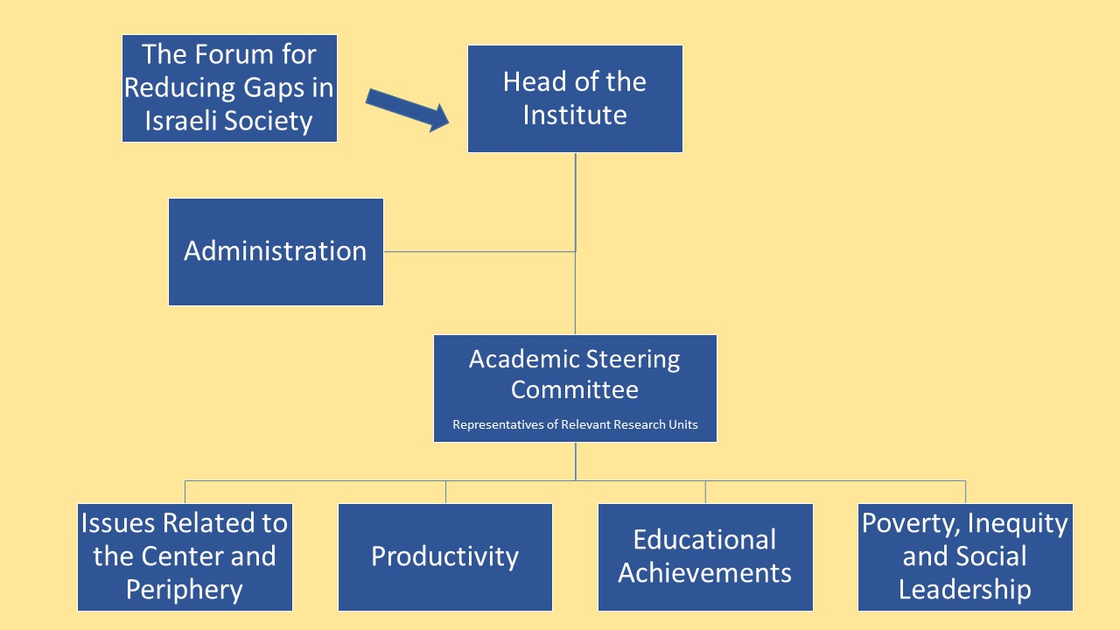

The structure of the institution is based on the following functions: Head of the Institute, Steering Committee, research work teams according to the definitions, and administrative support staff. The Head of the Institute will be appointed for a period of four years. The Institute will report to the Vice President and Dean of Research. An Academic Steering Committee comprising representatives of the relevant research units will oversee division of research tasks and their output.

**Work Processes**

The Institute's head will oversee the research activities and coordinate the research with the Forum for Reducing Gaps in Israel Society. The Institute's head will direct the activities of the Steering Committee and ensure allocation of resources and distribution of work among the research teams. The head of the Institute will report to the University of Haifa's Vice President and Dean of Research.

The Steering Committee will include representatives of research units from the Faculties of Social Sciences, Humanities, Social Welfare and Health Sciences, Education and Law. The representatives will train the research teams, which will focus on topics including poverty, inequality, social leadership; educational achievements, productivity, and issues relating to the center and periphery.

The research teams will be redefined from time to time, as per the needs of the Forum and the developments in the global economy and social changes vis-à-vis the COVID-19 crisis. Each team will be responsible for recruiting outstanding students and providing them with research scholarships. The teams will submit a 'call for proposals' that will be directed toward innovative and creative research initiatives that have scientific and applied value that address key social and economic challenges in Israeli society.

**Budget and Fundraising**

The Institute will receive independent funding and function under the auspices of the Research Authority. Its research activities will be financed by fundraising efforts conducted by The Forum for Reducing Gaps in Israel Society, the Manufacturers Association in Israel and the University of Haifa.

The Head of the Institute, Prof. Eran Vigoda-Gadot, will have the fiscal responsibility for the Institute's management and for allocation of resources, in accordance with the guidelines set by the Forum's management. Ms. Shira Ben-Or will be responsible for fundraising on behalf of the University and Mrs. Einat Dan on behalf of the Forum. Working together, we aim to raise one million dollars to support the initial phase.

**Work Plan**

The Institute will be established in two phases:

**Set-Up Phase**: Developing the infrastructure for the Academic Oversight Committee. This committee will comprise five senior researchers in the relevant areas. Each committee head will recruit research teams staffed by 10 researchers with expertise in each of the areas.

**Steady-State Phase**: After the initial sum of $1 million has been raised, the research teams will begin their research activities. Each team will define its own priorities and issue a ‘Call for Research’ proposals. The teams will review the proposals submitted and in coordination with the Forum, submit a multi-year plan prioritizing the projects to the Steering Committee. The projects will budget research scholarships for the students, and ongoing research activities within clear and defined objectives.

**Academic Leadership**

The head of the Institute will be a senior member of the University's Faculty with high academic standing in the field of social economic and public policy. The Institute head will be compensated according to guidelines determined by the University of Haifa. The Steering Committee will work on a voluntary basis.

**Senior Faculty members (partial list)**

|  |  |
| --- | --- |
| 1. Prof. Eran Vigoda-Gadot | Political Science, Public Management and Policy |
| 1. Prof. Shlomo Mizrahi | Political Science, Public Management and Policy |
| 1. Prof. Asad Ghanem | Political Science, Public Management and Policy |
| 1. Prof. Nissim Cohen | Political Science, Public Management and Policy |
| 1. Prof. Dana Vashdi | Political Science, Public Management and Policy |
| 1. Dr. Itai Beeri | Political Science, Public Management and Policy |
| 1. Dr. Yaniv Reingewertz | Political Science, Public Management and Policy |
| 1. Dr. Ayelet Banai | Political Science, Public Management and Policy |
| 1. Dr. Doron Navot | Political Science, Public Management and Policy |
| 1. Prof. Tally Katz Gerro | Sociology |
| 1. Prof. Meir Yaish | Sociology |
| 1. Prof. Yuval Yonai | Sociology |
| 1. Prof. Tali Kristal Sociology | Sociology |
| 1. Dr. Aliza Lewin | Sociology |
| 1. Dr. Asaf Levanon | Sociology |
| 1. Dr. Amid Saabana | Sociology |
| 1. Prof. Ilan Talmud | Sociology |
| 1. Dr. Asa Maron | Sociology |
| 1. Prof. Rivka Reichman | Sociology |
| 1. Dr. Tal Orton Bergman | Social Work |
| 1. Dr Adital Ben Arie | Social Work |
| 1. Dr Ruth Berkovitz | Social Work |
| 1. Dr Hani Neuman | Social Work |
| 1. Prof. Roni Strier | Social Work |
| 1. Prof. Faisal Azaiza | Social Work |
| 1. Dr. Mica Koreh | Social Work |
| 1. Prof. Amalia Saar | Anthropology |
| 1. Dr. Tsipi Ivri | Anthropology |
| 1. Dr. Nadeem Karkabi | Anthropology |
| 1. Dr. Devorah Golden | Education |
| 1. Dr. Barri Rutenberg | Education |
| 1. Dr. Oren Gazal-Eyal | Law |
| 1. Prof. Gadi Barzilai | Law |
| 1. Dr. Michal Gal | Law |
| 1. Dr. Tami Harel Ben- Shahar | Law |
| 1. Dr. Alan Miller | Law |
| 1. Dr. Itamar Mann | Law |
| 1. Prof. Noya Rimalt | Law |
| 1. Dr. Ori Shai | Economics |
| 1. Dr. Jacob Schwartz | Economics |
| 1. Dr. Amnon Maltz | Economics |
| 1. Dr. Binyamin Bachi | Economics |