

**Advancing Social Mobility at the University of Haifa:**

***Changing the Lives of Students from***

***Socio-Economically Disadvantaged Backgrounds***

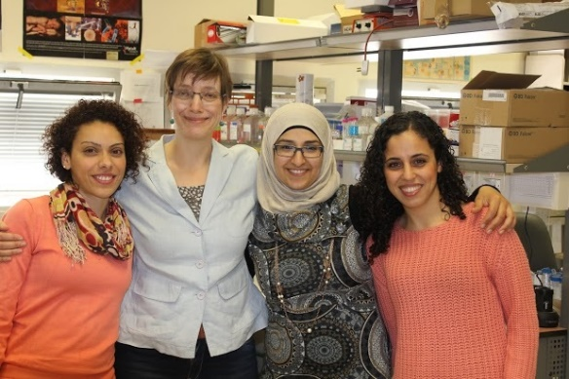

**Executive Summary**

In view of the disproportionate impact that COVID-19 has had on lower-income households, the University of Haifa is launching a campus-wide initiative that will promote social mobility for under-represented students from Israel's geographic and social periphery. A team of University of Haifa researchers, psychologists, career counselors and dedicated administrative staff will develop a holistic, multidisciplinary academic model with a corresponding student support system that will serve as the basis for promoting inclusion and social mobility policies – first, at the University of Haifa and then at Israeli universities and colleges throughout the country. **The University of Haifa is the first university in Israel to define social mobility as a high-priority strategic action**.

**Background**

According to the Organization for Economic Co-operation and Development, the State of Israel is among the most unequal economies in the western world. In Israel, only 15% of motivated, minority students with low matriculation (*bagrut*) scores have access to higher education. Many of these students struggled academically during high school because they worked to support their families or grew up in challenging home environments. As a result, industrious members of Israeli society are unable to reach their fullest potential and social inequalities are maintained. **"We believe that an inclusive system of higher education, with an emphasis on academic excellence for students from a variety of backgrounds, offers a critical engine for social mobility, interethnic co-existence and strengthening Israeli society,"** says President Ron Robin.

**Vision, Goals and Organizational Structure**

The Campus-Wide Social Mobility Initiative will strive to empower, expand, and redefine the role of Israeli higher education as an engine for change – enabling the pursuit of justice and social equality in the spirit of the Declaration of Independence. The organizational framework will bring together all relevant university stakeholders to develop inclusion plans and leverage existing services to ensure that these students are provided a comprehensive "envelope" of financial, academic, linguistic and social support throughout their studies. A crucial component of the initiative includes career counselling programs that will help them successfully integrate into the employment market.

**What Makes this Program Unique?**

* Leadership: Professor Roni Strier, an international expert in poverty and social mobility, will be leading the initiative. Given his extensive research and practical fieldwork, the University of Haifa has gained significant expertise in the area of education as a means toward advancing social mobility.
* A holistic, institution-wide approach: Prof. Strier will lead a Steering Committee comprised of key personnel from various University departments that work directly with students from disadvantaged backgrounds. The committee will meet monthly to ensure that all activities and services are coordinated and directed toward the goal of advancing social mobility.
* Respecting multicultural differences: Evaluating the model's initiatives, activities and impact in a multicultural environment.
* Individualized interventions: Monitoring and customizing the support "envelope" according to each student's individual needs and characteristics.

**Pilot Year: Taking Student Feedback Seriously**

To ensure that the Campus-Wide Social Mobility Initiative meets the needs of under-represented students, we plan to operate the first year as a pilot year. The 30 students accepted into the program will play an important role in co-creating the initiative. We plan to interview the students – individually and in group settings – throughout the year to get their feedback on a range of topics including the recruitment, application and acceptance processes; their transition to academic life; the quality of student support, tutoring and psychological services; as well as the special mentoring they will receive from faculty members. Gaps we identify will be addressed promptly to strengthen the initiative.

**Timeline: Year 1 – 2020-2021**

|  |  |  |  |  |
| --- | --- | --- | --- | --- |
|  | July-Sept | Oct-Feb | March-June | July-Oct |
| Publicize Initiative |  |  |  |  |
| Establish Steering Committee |  |  |  |  |
| Hire Program Leadership Team |  |  |  |  |
| Develop Support "Envelope" |  |  |  |  |
| Develop Evaluation Plan |  |  |  |  |
| Recruit Students |  |  |  |  |
| Gather Baseline Data |  |  |  |  |
| Program Launch |  |  |  |  |
| Implement Support Services |  |  |  |  |
| Steering Committee (monthly) |  |  |  |  |
| Program Evaluation |  |  |  |  |
| Fine-Tune Support Services |  |  |  |  |
| Fine-Tune Evaluation Plan |  |  |  |  |
| Host National Conference |  |  |  |  |
| Recruit 2nd Cohort |  |  |  |  |

**About the University of Haifa**

Over 18,000 students from a wide range of ethnic and socio-economic backgrounds are enrolled at the University of Haifa, the largest comprehensive research university in northern Israel, and the most pluralistic institution of higher education in the country.

The University’s distinctive mission is to foster academic excellence in an atmosphere of tolerance and multiculturalism. Our faculty and student population is unique in its composition. Here, Jews, Arabs, Druze, Haredi and secular students, new immigrants, and military and security personnel come together to study, teach and learn.

Driven by unusual crossings between fields of research and social responsibility we create a new environment, a better community, and a better Israeli society.

