|  |  |  |  |  |  |  |  |  |
| --- | --- | --- | --- | --- | --- | --- | --- | --- |
| |  | | --- | |  | | THE LEGAL CLINICs: ensuring that Refugees have legal representation  The asylum-seeking community in Israel numbers some 36,000 men, women and children. Most non-Jewish African asylum-seekers have been granted "conditional release" visas, which are not valid work permits in Israel. With limited economic opportunities, cultural and language barriers, and difficulties navigating the Israeli legal system, the community urgently needs compassionate and high-quality legal representation.  The Legal Clinics for Law and Social Change were established with the aim of utilizing law to promote social justice and educate the next generation of ethical, socially responsible lawyers. Recently, the Clinics have taken on more *pro bono* cases to assist Israel's refugee and asylum-seeking community.  **THE CLINICS SUPPORT UN SUSTAINABILITY GOAL #16 – PEACE, JUSTICE AND STRONG INSTITUTIONS. (see appendix)** | |  | |  | |  | | --- | | providing legal aid for members of the refugee communitypreparing LAW students for REAL WORLD CHALLENGESutilizing law to promote human rightsensuring the rule of law through policy and legislative changes | |  | | "University of Haifa is guided by the foundational values of shared society and social responsibility."   * President Ron Robin | |

**Ensuring that Refugees have Legal Representation**

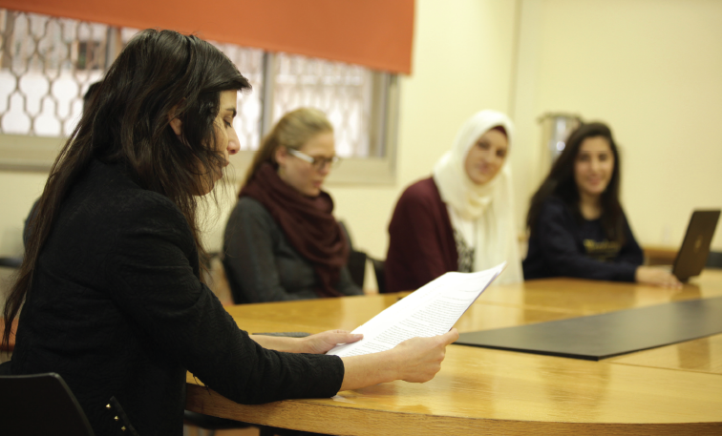

**Background**

The Legal Clinics aim to have a positive impact on Israeli society. Our faculty members and students promote human rights and access to justice by engaging in some of the most pressing issues of human rights in Israel, and giving legal aid to members of marginalized communities including Arab-Palestinians and refugees from South Africa.

We believe in the power of experiential legal education. The seven clinics enroll about 100 second and third year law students who, with the guidance and supervision of experienced and leading lawyers, deal with over 500 cases each year and take on legislative reform projects that can affect the lives of thousands.

One of the most marginalized populations in Israel and worldwide are refugees and other undocumented individuals. The Legal Clinics stand at the forefront of legal aid to this population, in Haifa, in Israel, and even abroad. The activity involves three main projects in which various clinics participated.

**The Clinic for Human Rights in Society**

The Clinic for Human Rights in Society promotes the human rights of marginalized communities in Israel and beyond, including people in poverty, the Arab Palestinian minority, people with disabilities and refugees. The Clinic works on a variety of legal topics that are crucial to the wellbeing of impoverished and marginalized individuals such as housing, legal status and social security rights.

***Legal Aid to Refugees in Greece***

In partnership with European organizations supplying legal, social and medical aid to refugees in Europe, the Clinic provided legal aid and legal translation to refugees in Greece. Haifa’s multicultural population includes many Arab speaking students and clinical staff, who could provide much needed assistance to the local organizations. In a three-year period (2018-2020), students and staff from the clinic embarked on six trips to Greece, three weeks each, after thorough preparation in Israel concerning the relevant legal material and mental preparation.

In Greece (mostly in Chios, and in Athens in January 2020), the students helped asylum seekersprepare their documents and practice for the interview, and also helped write reports on various legal issues concerning asylum seekers rights. Due to the Coronavirus pandemic, this project has been put on hold. We look forward to resuming as soon as it is medically safe to do so.

Their work in Greece demonstrated to clinic volunteers that even when faced with the biggest challenges, even one person can make a difference:

*"This experience has shown me what I am capable of. Even though I don't have enough money to give them, I realized that I can help with the knowledge that I acquired during my studies. I can tell you for sure that after I finish [my studies], I will be involved more in international and national community to provide help for vulnerable groups."*

* Dumiana, fourth-year law student

*"I came from the Druze society that goes to the army here in Israel. We don't have a connection with Arab society in Israel or our Arab neighbors. At first, I didn't want the refugees we were helping to know that I was a Druze, but they recognized my accent. Their reaction was lovely, and it surprised me. It made me look at them differently."*

* Nasrin, a third-year law student

***Undocumented Legal Aid Center – Hadar Neighborhood, Haifa***

The Legal Clinics run a walk-in rights’ center in the neighborhood of Hadar that serves refugees and undocumented individuals. The Center was established in partnership with a student-led health clinic run by the Technion's Faculty of Medicine. Students from four clinics, led by the Human Rights Clinic, receive clients at the Center twice a week in three-hour shifts and offer general legal aid. Asylum seekers and undocumented individuals often have complex multilayered untreated legal problems and the walk-in clinic is the only legal aid they can access.

The cases that the students deal with range from legal status in Israel, access to health care (since many of the clients do not have health care insurance), housing, debt, education and labor law. Women asylum seekers face additional challenges, for example, they may be vulnerable to domestic violence and have no access to social services or are often afraid to contact the police.

In addition, Israel has a large undocumented Palestinian population, many of whom have lived in Haifa for many years without legal status or health care insurance. For example, the clinics represented a Palestinian man who was suspected of collaborating with the IDF and therefore has been living in Israel for 15 years. The client has complicated health issues and does not have health insurance because he was granted only temporary sixth-month visas that do not include eligibility for health insurance. As a result, the man accumulated significant debt. At a certain point, the Ministry of Defense stopped issuing his visa. In April 2020, the Clinic for Human Rights in Society, together with the Clinic for the Rights of the Arab–Palestinian minority, filed a petition on his behalf with the Tel Aviv Administrative Court. Following the intervention, the state decided to renew the client’s visa.

The Clinics have gained experience through individual legal aid, enabling them to engage in outreach and creating information for the public. For example, during lockdown, the Clinic created a guide for asylum seekers and for organizations that help them detailing coronavirus-related aid available from different governmental units that was relevant for asylum seekers.

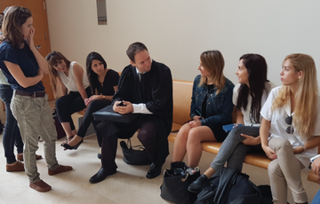  
***Legal Clinic students meet with their professional advisor.***

**The Legal Clinic for Law and Educational Policy**

The Legal Clinic for Law and Educational Policy promotes equal opportunity in education and engages in high impact litigation, legislation drafting and advocacy. Projects include: access to equal education for refugees; inclusion of children disabilities; equality in admission policies; educational equality for the Arab-Palestinian community; and ensuring free public education.

***Asylum Seekers’ Right to Education***

According to Israeli law, as well as Israel’s international obligations, all children residing in Israel, regardless of their legal status, are entitled to free public education. Despite this obligation, many cities in Israel try to prevent asylum seeking children from enrolling in schools and kindergartens, or illegally assign them to kindergartens and schools that are segregated.

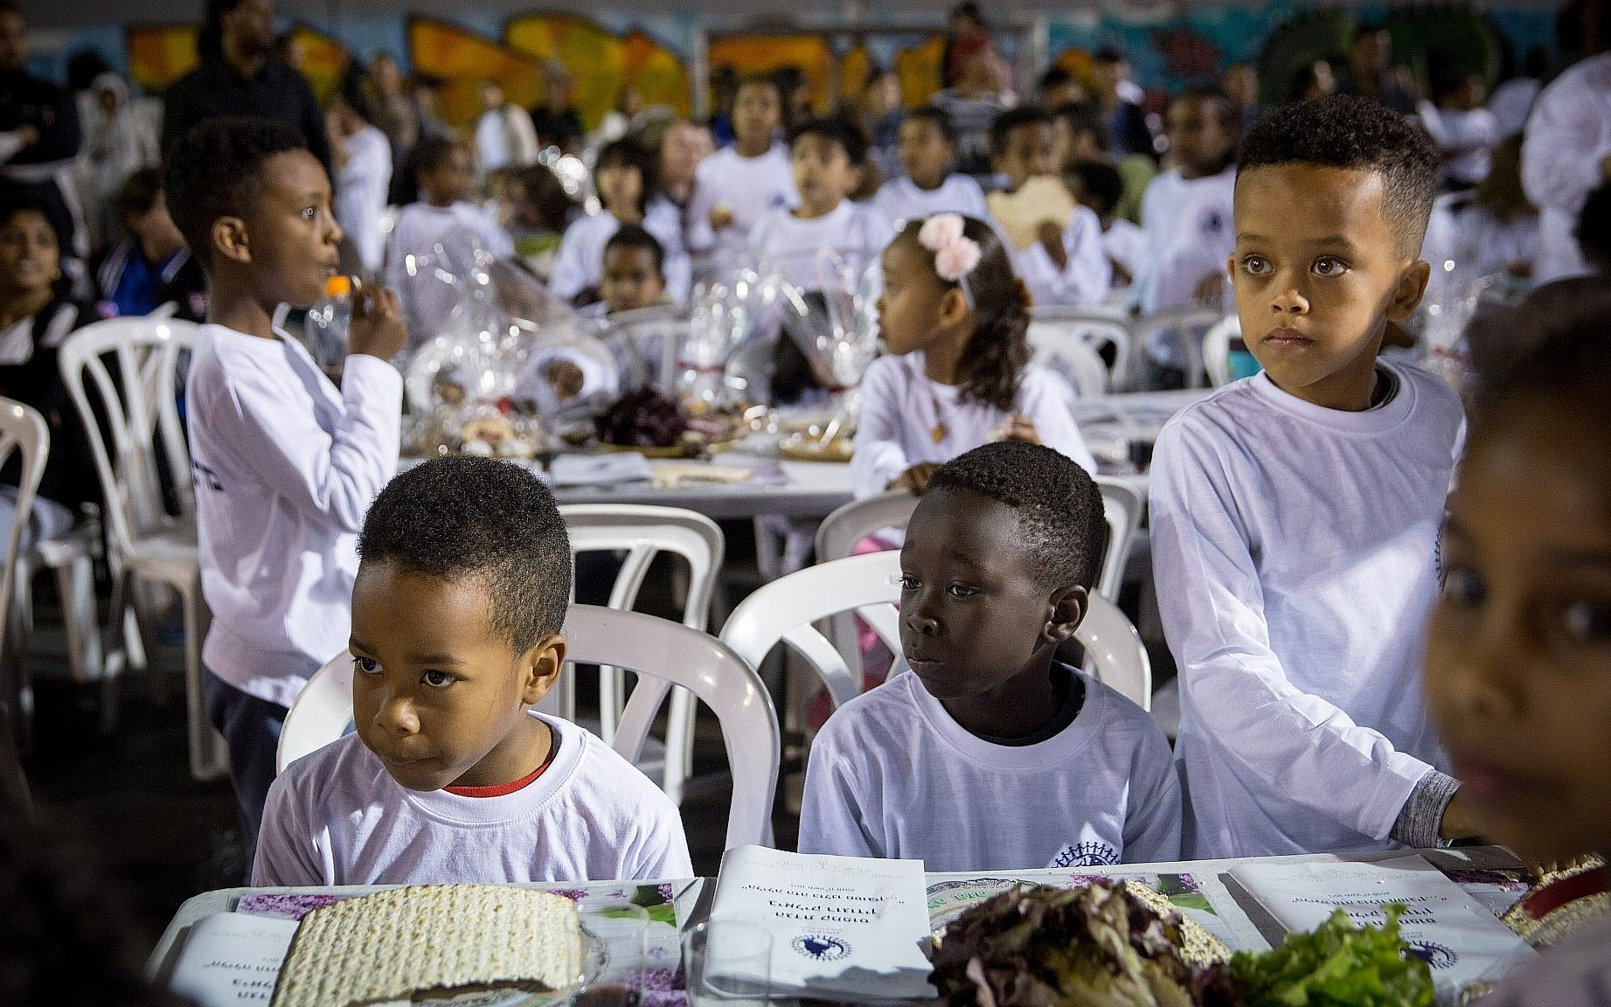Since 2014, the Clinic has represented hundreds of asylum seeking families in multiple cities in Israel (including Kiryat Malachi, Netanya, Petah Tiqva, Lod, Bnei Barak, and Tel Aviv) and filed multiple petitions on their behalf. Since the law clearly mandates equal enrolment, our petitions have been successful every time. Despite our actions, some municipalities continue to discriminate against asylum seekers and erect barriers to their integration into mainstream schools. For example, the Clinic has had to file three separate petitions against the city of Petah Tiqva (2016, 2019, 2020), as well as a request to find the city in contempt of the court for not complying with the court order.

On August 3rd 2021, the Clinic filed a petition against the city of Tel-Aviv’s policy of enrolling asylum seeker children in segregated kindergartens and schools. Of Tel Aviv’s large asylum seeker population, only a small minority attend schools and kindergartens that are not “ghetto schools”, in other words schools that serve only children from South Africa. The petition, filed on behalf of hundreds of asylum seeker children as well as several human rights’ organizations, and carries the symbolic name of “Brown v. Tel Aviv” (because the first petitioner’s surname is Brown), is supported by briefs from education and psychology experts detailing the irreparable damage caused to children by school segregation. The petition is pending.

**Academic Leadership**

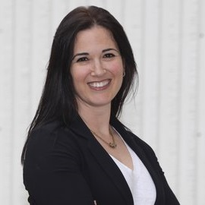Dr. Tammy Harel Ben Shahar is a lecturer at the Faculty of Law, and the Academic Director of the Clinics for Law and Social Change. Dr. Harel Ben Shahar completed her LLD at the Hebrew University Law Faculty. Her dissertation on Equality in Education and the Privatization of Education won the Bronfman prize for outstanding dissertation in the Humanities, Social Sciences and Law.

After completing her doctoral studies, Harel Ben Shahar spent two years as a post-doctoral scholar at Columbia University and at the Tikvah Center in the NYU School of Law as a Fulbright fellow. Her scholarship engages issues in the intersection between Law and Philosophy, and focuses especially on Education Law and Philosophy, Distributive Justice, Human Rights, and Political Philosophy.

*We thank you for your consideration of this request.*

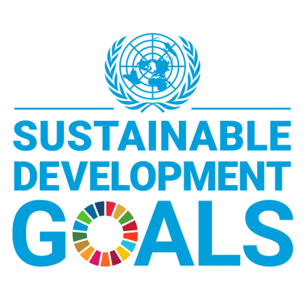

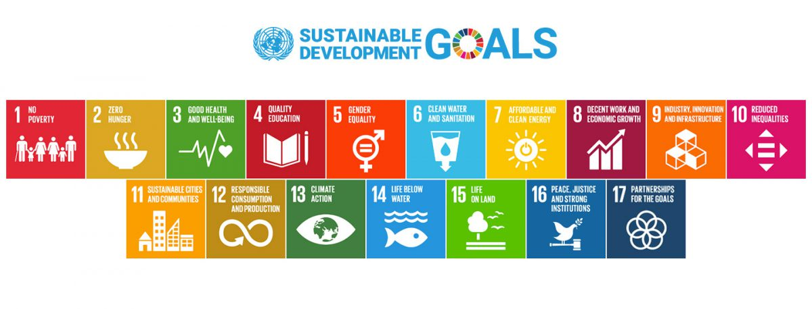

|  |
| --- |
| **University of Haifa is committed to the UN's 17 Sustainable Development Goals (SDGs) and is actively participating in global efforts that aim to create a better future for the planet, humanity and Israeli society.** |

The Sustainable Development Goals were adopted by the United Nations in 2015 as a universal call to action to end poverty, protect the planet, and ensure that by 2030 all people enjoy peace, health and prosperity.

Universities have a unique and critical role in helping the world achieve the Sustainable Development Goals through their research, teaching, operations and community engagement.

University of Haifa is the first Israeli higher education institution that is committed to undertaking research, providing relevant educational opportunities and operating its campuses in a manner that is making a positive contribution to achieving the SDGs.

